CYBER SECURITY- VIRTUALIZATION AND CLOUD BASICS

HACKERS AND HACKING METHODOLOGIES
TASK1:
List 3 common hacking methodologies (such as phishing, brute force, SQL injection) and for each, write one real-world example of how it could be used to compromise an account on an app like Instagram or Paytm.
Three common hacking methods are Phishing, Brute Force, and SQL Injection.
Method | Simple Meaning | Real-world example
Phishing | Attacker creates a fake message or website to trick the user into giving login details. | An attacker may send a fake Instagram login link through email or WhatsApp. If the victim enters their username and password, the attacker can receive those details.
Brute Force | Attacker tries many possible passwords or PINs until the correct one is found. | If an account has a weak 4-digit PIN and proper login limits are not present, an attacker may try many PIN combinations.
SQL Injection | Attacker places harmful SQL input into a vulnerable website form to access or change database information. | If a poorly protected payment or shopping website has a vulnerable login form, an attacker could try specially crafted input to access database information.

TASK2: Simulate a simple brute force attack by writing a Python script that tries all 4-digit PIN combinations (0000-9999) to guess a preset password variable. Print the number of attempts taken to find the correct PIN.<br><br><em><strong>Constraint:</strong> Do not use external libraries for this task.</em>
correct_pin = "5728"
attempts = 0

for number in range(10000):
pin = f"{number:04d}"
attempts += 1

if pin == correct_pin:
print("Correct PIN found:", pin)
print("Number of attempts:", attempts)
break

- correct_pin stores the preset PIN.
- range(10000) generates numbers from 0 to 9999.
- f"{number:04d}" converts the number into a 4-digit format.
- The program checks each PIN one by one.
- When the correct PIN is found, it prints the PIN and number of attempts.
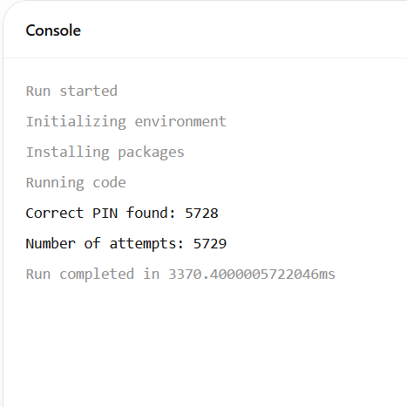
There are 10,000 possible 4-digit PINs, from:
0000
0001
0002
...
9999

TASK3: Research and describe the steps involved in a phishing attack targeting users of a popular food delivery app like Zomato or Swiggy. Include at least 4 steps and explain what the attacker and victim do at each stage.
Step 1: Creating a Fake Message
"Your food order has been cancelled. Click here to get your refund."
The message contains a link to a fake website.
Victim: Receives the message and may believe that it is a genuine message from the food-delivery service.

Step 2: Victim Opens the Link
Attacker: Uses a fake website designed to look similar to the real service.
Victim: Clicks the link and opens the fake page.

Step 3: Fake Login or Payment Page
Attacker: The fake page asks for information such as username, password, phone number or payment-related details.
Victim: Enters the requested information believing that the page is genuine.

Step 4: Information Is Sent to the Attacker
Attacker: The information entered into the fake page can be captured by the attacker's system.
Victim: May continue using the page without realizing that the information has been collected.

Step 5: Misuse of Information
Attacker: May attempt to use stolen credentials for account access or other fraud.
Victim: Could lose access to the account or face financial loss if additional security controls are not present.

How to Stay Safe
- Check the website address carefully.
- Do not open suspicious refund or coupon links.
- Never share OTPs or passwords.
- Use the official app or website.
- Enable two-factor authentication where available.

TASK4: Given the following fake login page HTML code, identify and explain two ways a hacker could use this page for credential harvesting.<br><br><em><strong>Hint:</strong> Think about what happens to the data entered by the user and how it could be sent to an attacker.</em>
Method 1: Sending Entered Data to an Attacker's Server
A fake login page can contain a form. When the victim enters a username and password, the form can be designed to send the entered information to another server controlled by the attacker.
Victim enters username + password
↓
Fake Login Form
↓
Data is submitted
↓
Attacker's server
Method 2: Saving Credentials in a Database/File
The fake page can also be connected to a backend program that stores the submitted information.
EX: Username → victim@example.com
Password → ********
Main Idea
A fake login page can therefore be dangerous because:
- The entered information can be transmitted to another server.
- The entered information can be stored for later misuse.

TASK5: Use ChatGPT or another AI tool to generate a list of 5 recent real-world hacking incidents involving Indian apps or websites. For each incident, write one line about the hacking methodology used.
No. | App / Website / Organization | Year | Methodology used
1 | Moneyview App | 2025 | Bengaluru police said attackers breached the app's API system/API key and diverted funds to fake and mule accounts.
2 | Zoomcar | 2025 | Zoomcar confirmed unauthorised access to its information systems; reports said personal information of about 84 lakh users was affected. The specific initial intrusion method was not publicly established in the cited report.
3 | KiranaPro | 2025 | The company suffered a major data wipe; its CEO said an investigation pointed toward a former employee, although the report noted that concrete evidence had not been publicly presented.
4 | mParivahan fake-app campaign | 2025 | Attackers distributed a cloned Android APK through messages. The malicious app requested permissions and was reported to steal sensitive information and enable fraudulent transactions.
5 | ICAR website and servers | 2025 | ICAR suffered a security breach affecting its website and servers, resulting in loss of important data. The cited report did not establish a specific initial attack technique.

